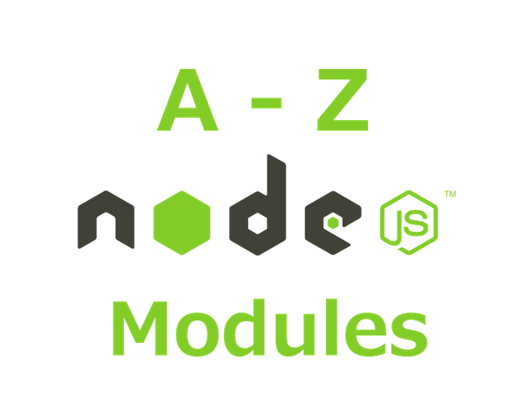
A to Z List of Useful Node.js Modules

Introduction - Node.js
Node.js is an open source platform for creating applications that uses JavaScript on server side as well as on the client side. JavaScripts usage amongst the developer community is growing at a very rapid pace. It is the most popular language in a recent survey conducted by Stack Overflow.
Its runtime environment interprets JavaScript using Google's V8 JavaScript engine. Node.js has an event-driven architecture capable of asynchronous I/O that makes it lightweight and efficient. Node.js' package ecosystem, npm, is the largest ecosystem of open source libraries in the world.
Here is a A to Z list of node modules that will extend the capability of your node.js application.
A
- Async: Async is a utility module which provides straight-forward, powerful functions for working with asynchronous JavaScript.
B
- Browserify: Browserify will recursively analyze all the require() calls in your app in order to build a bundle you can serve up to the browser in a single <script> tag.
- Bower: Bower is a package manager for the web. It works by fetching and installing packages from all over, taking care of hunting, finding, downloading, and saving the stuff you’re looking for.
- Backbone: Backbone.js gives structure to web applications by providing models with key-value binding and custom events, collections with a rich API of enumerable functions, views with declarative event handling, and connects it all to your existing API over a RESTful JSON interface.
C
- Csv: csv module has four sub modules which provides CSV generation, parsing, transformation and serialization for Node.js.
D
- Debug: Debug is a tiny node.js debugging utility modelled after node core's debugging technique.
E
- Express: Express is a fast, un-opinionated, minimalist web framework. It provides small, robust tooling for HTTP servers, making it a great solution for single page applications, web sites, hybrids, or public HTTP APIs.
F
- Forever: A simple CLI tool for ensuring that a given node script runs continuously (i.e. forever).
G: Grunt and Gulp do exactly the same thing. Grunt has been around longer than Gulp.
- Grunt: is a JavaScript Task Runner that facilitates creating new projects and makes performing repetitive but necessary tasks such as linting, unit testing, concatenating and minifying files (among other things) trivial.
- Gulp: is a streaming build system that helps you automate painful or time-consuming tasks in your development workflow.
H
- Hapi: is a streaming build system that helps you automate painful or time-consuming tasks in your development workflow.
- Http-server: is a simple, zero-configuration command-line http server. It is powerful enough for production usage, but it's simple and hackable enough to be used for testing, local development, and learning.
I
- Inquirer: A collection of common interactive command line user interfaces.
J
- Jquery : jQuery is a fast, small, and feature-rich JavaScript library.
- Jshint : Static analysis tool to detect errors and potential problems in JavaScript code and to enforce your team's coding conventions.
K
- Koa: Koa is web app framework. It is an expressive HTTP middleware for node.js to make web applications and APIs more enjoyable to write.
L
- Lodash: The lodash library exported as a node module. Lodash is a modern JavaScript utility library delivering modularity, performance, & extras.
- Less: The less library exported as a node module.
M
- Moment: A lightweight JavaScript date library for parsing, validating, manipulating, and formatting dates.
- Mongoose: It is a MongoDB object modeling tool designed to work in an asynchronous environment.
- MongoDB: The official MongoDB driver for Node.js. It provides a high-level API on top of mongodb-core that is meant for end users.
N
- Npm: is package manager for javascript.
- Nodemon: It is a simple monitor script for use during development of a node.js app, It will watch the files in the directory in which nodemon was started, and if any files change, nodemon will automatically restart your node application.
- Nodemailer: This module enables e-mail sending from a Node.js applications.
O
- Optimist: is a node.js library for option parsing with an argv hash.
P
- Phantomjs: An NPM installer for PhantomJS, headless webkit with JS API. It has fast and native support for various web standards: DOM handling, CSS selector, JSON, Canvas, and SVG.
- Passport: A simple, unobtrusive authentication middleware for Node.js. Passport uses the strategies to authenticate requests. Strategies can range from verifying username and password credentials or authentication using OAuth or OpenID.
Q
- Q: Q is a library for promises. A promise is an object that represents the return value or the thrown exception that the function may eventually provide.
R
- Request: Request is Simplified HTTP request client make it possible to make http calls. It supports HTTPS and follows redirects by default.
S
- Socket.io: Its a node.js realtime framework server.
- Sails : Sails : API-driven framework for building realtime apps, using MVC conventions (based on Express and Socket.io)
T
- Through: It enables simplified stream construction. It is easy way to create a stream that is both readable and writable.
U
- Underscore: Underscore.js is a utility-belt library for JavaScript that provides support for the usual functional suspects (each, map, reduce, filter...) without extending any core JavaScript objects.
V
- Validator: A nodejs module for a library of string validators and sanitizers.
W
- Winston: A multi-transport async logging library for Node.js
- Ws: A simple to use, blazing fast and thoroughly tested websocket client, server and console for node.js
X
- Xml2js: A Simple XML to JavaScript object converter.
Y
- Yo: A CLI tool for running Yeoman generators
Z
- Zmq : Bindings for node.js and io.js to ZeroMQ .It is a high-performance asynchronous messaging library, aimed at use in distributed or concurrent applications.

For testing: I will say Chai, Sinon, Jasmin, Mocha etc

